PROJECT FINAL REPORT
Project Title
Streamlining IT Procurement: Automating Standard Laptop Orders with Flow Designer
1. INTRODUCTION
1.1 Project Overview
The Streamlining IT Procurement: Automating Standard Laptop Orders with Flow Designer project is a ServiceNow-based automation solution designed to simplify and standardize the process of requesting standard laptops within an organization.
In a traditional IT procurement process, employees may need to submit requests manually, and IT or procurement teams may need to review the request, create fulfillment tasks, assign them to the appropriate team, and update the request status manually. This can result in additional effort, delays, and inconsistent processing.
The proposed solution uses ServiceNow Service Catalog and Flow Designer to automate the creation of a laptop procurement task. When an employee selects the Standard Laptop catalog item and clicks Order Now, the Service Catalog request triggers a Flow Designer workflow. The flow automatically creates a Catalog Task and populates the required information, including the short description, description, assignment group, and approval value.
The main workflow is:
Service Catalog → Standard Laptop → Order Now → Request → Requested Item → Flow Designer → Create Catalog Task → Hardware Assignment
The project demonstrates how ServiceNow automation can reduce manual activities and provide a consistent workflow for standard IT equipment requests.
1.2 Purpose
The purpose of this project is to develop an automated ServiceNow workflow for standard laptop procurement.
The major objectives are:
- To provide a Standard Laptop item through the Service Catalog.
- To allow employees to submit laptop requests easily.
- To automatically trigger a Flow Designer workflow when a request is submitted.
- To automatically create a Catalog Task for the laptop request.
- To assign the task to the Hardware group.
- To automatically populate the required task information.
- To reduce manual intervention in the procurement process.
- To improve consistency and traceability of laptop requests.
- To simplify the overall IT procurement workflow.
2. IDEATION PHASE
2.1 Problem Statement
Organizations frequently receive requests from employees for IT equipment such as laptops. When these requests are processed manually, IT teams may have to perform several repetitive activities, including reviewing requests, creating tasks, assigning tasks, and updating request information.
The absence of an automated workflow can result in:
- Increased manual effort.
- Delays in processing requests.
- Incorrect or incomplete task information.
- Inconsistent assignment of requests.
- Difficulty tracking the progress of requests.
- Repetitive administrative work for IT support teams.
Problem Statement
How can the standard laptop procurement process be automated in ServiceNow so that a user's laptop request automatically generates the required fulfillment task and assigns it to the appropriate Hardware team?
The project addresses this problem using ServiceNow Service Catalog and Flow Designer.
2.2 Empathy Map Canvas
The empathy map identifies the needs and experiences of the main users involved in the laptop procurement process.
Category | User Perspective
Says | "I need a standard laptop for my work."
Thinks | "I want my request to be processed quickly and correctly."
Does | Opens the Service Catalog, selects Standard Laptop, and submits the request.
Feels | Wants a simple request process and visibility into the request status.
Pain Points | Manual request processing, delays, lack of visibility, repeated communication.
Needs | Simple request submission, automatic processing, correct task assignment, and status tracking.
IT/Hardware Team Perspective
Category | User Perspective
Says | "Laptop requests should reach the Hardware team with the required information."
Thinks | "Manual task creation takes unnecessary time."
Does | Reviews requests and performs laptop fulfillment activities.
Feels | Needs consistent and organized task assignment.
Pain Points | Repetitive task creation and incorrect/incomplete request information.
Needs | Automatically generated and correctly assigned Catalog Tasks.

2.3 Brainstorming
During brainstorming, several possible approaches were considered for improving the laptop procurement process.
Ideas Considered
- Manual email-based laptop requests.
- Manual ServiceNow request processing.
- Service Catalog-based laptop request.
- Automated task creation using Flow Designer.
- Automated notifications for request status.
- Automatic assignment of laptop requests to the Hardware team.
- Automated approval handling.
- End-to-end procurement workflow automation.
Selected Idea
The selected solution was to use ServiceNow Service Catalog with Flow Designer because it provides a structured request interface and allows workflow activities to be automated without requiring extensive custom programming.
3. REQUIREMENT ANALYSIS
3.1 Customer Journey Map
Stage | User Activity | System Activity | User Experience
1. Identify Need | Employee needs a laptop | — | Needs an easy way to request equipment
2. Open Catalog | Employee opens Service Catalog | Displays available catalog items | Can view available services
3. Select Item | Selects Standard Laptop | Displays laptop request | Simple selection
4. Submit Request | Clicks Order Now | Creates Request and Requested Item | Request is submitted
5. Automation | Waits for processing | Flow Designer is triggered | No manual intervention required
6. Task Creation | — | Catalog Task is automatically created | Request progresses
7. Assignment | — | Task is assigned to Hardware | Correct team receives task
8. Fulfillment | Hardware team processes task | Task status is updated | Request can be tracked
9. Completion | Employee receives laptop | Request reaches completion | Procurement process completed

3.2 Solution Requirement
Functional Requirements
FR-01: Service Catalog Item
The system shall provide a Standard Laptop catalog item under the Hardware category.
FR-02: Request Submission
The user shall be able to select the Standard Laptop item and submit the request using Order Now.
FR-03: Flow Trigger
The ServiceNow Flow Designer flow shall be triggered when the Service Catalog request is submitted.
FR-04: Catalog Task Creation
The flow shall automatically create a Catalog Task for the Requested Item.
FR-05: Short Description
The Catalog Task shall contain:
Laptop need to Configured
FR-06: Description
The Description field shall contain:
Laptop need to Configured
FR-07: Assignment Group
The Catalog Task shall be assigned to:
Hardware
FR-08: Approval
The Approval field shall be configured as:
Approved
FR-09: Request Tracking
The user shall be able to view the Request, Requested Item, and associated Catalog Task.
Non-Functional Requirements
Requirement | Description
Usability | The request process should be simple and easy to understand.
Reliability | The flow should execute consistently for Standard Laptop requests.
Maintainability | Flow configuration should be easy for ServiceNow administrators to maintain.
Automation | Manual Catalog Task creation should be minimized.
Traceability | Requests and tasks should be trackable through ServiceNow records.
Performance | The flow should execute without errors or unnecessary delays.
Security | The workflow should follow ServiceNow access and role permissions.

3.3 Data Flow Diagram
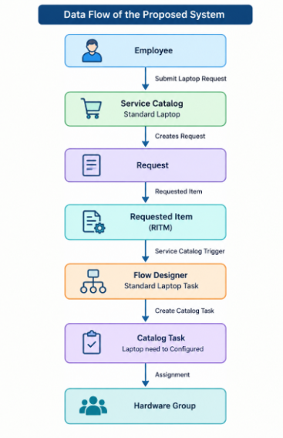
3.4 Technology Stack
Technology | Purpose
ServiceNow | Main development platform
Service Catalog | Provides the Standard Laptop request item
Flow Designer | Automates the laptop procurement workflow
Catalog Item | Represents the Standard Laptop request
Requested Item (RITM) | Stores the submitted request
Catalog Task | Represents the fulfillment task
Hardware Group | Receives the automatically generated task
ServiceNow Database | Stores requests, Requested Items, and Catalog Tasks
Web Browser | Used to access and operate the ServiceNow instance

4. PROJECT DESIGN
4.1 Problem Solution Fit
The proposed solution directly addresses the identified problems in manual laptop procurement.
Problem | Proposed Solution
Manual request processing | Service Catalog
Manual task creation | Flow Designer
Incorrect task assignment | Automatic Hardware group assignment
Repetitive data entry | Automatic field population
Lack of tracking | ServiceNow Request/RITM/Catalog Task records
Processing delays | Automated workflow
Inconsistent task information | Predefined task values
The solution provides a structured and automated method for processing standard laptop requests.

4.2 Proposed Solution
The proposed solution consists of the following components:
Step 1: Standard Laptop Catalog Item
A Standard Laptop catalog item is created under the Hardware category.
Step 2: User Request
The employee opens the Standard Laptop catalog item and selects Order Now.
Step 3: Request Creation
ServiceNow creates a Request and corresponding Requested Item.
Step 4: Flow Trigger
The Service Catalog request triggers the Standard Laptop Task flow.
Step 5: Catalog Task Creation
The Flow Designer uses the Create Catalog Task action.
Step 6: Task Configuration
The task is populated with:
- Short Description: Laptop need to Configured
- Description: Laptop need to Configured
- Assignment Group: Hardware
- Approval: Approved
Step 7: Fulfillment
The Hardware team receives the Catalog Task and processes the laptop request.
4.3 Solution Architecture
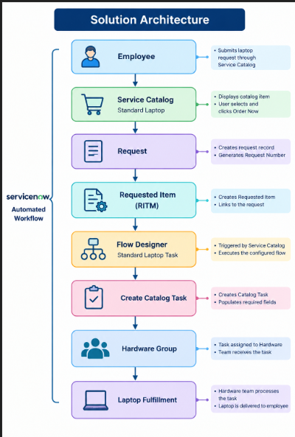
5. PROJECT PLANNING & SCHEDULING
5.1 Project Planning
Phase | Activity | Deliverable
Phase 1 | Requirement Analysis | Project requirements
Phase 2 | Problem Identification | Problem statement
Phase 3 | Ideation | Proposed automation approach
Phase 4 | ServiceNow Setup | Development environment
Phase 5 | Catalog Configuration | Standard Laptop catalog item
Phase 6 | Flow Development | Standard Laptop Task flow
Phase 7 | Integration/Configuration | Catalog Item connected to Flow
Phase 8 | Functional Testing | Test results
Phase 9 | UAT | UAT report
Phase 10 | Documentation | Final project report
Development Workflow
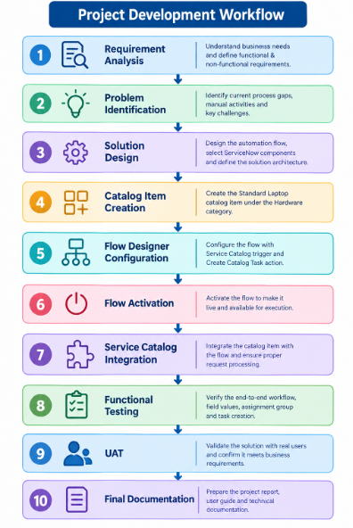

6. FUNCTIONAL AND PERFORMANCE TESTING
6.1 Performance Testing
Test Case ID | Test Scenario | Expected Result | Result
FT-01 | Open Standard Laptop | Catalog item should open | Pass
FT-02 | Submit laptop request | Request should be created | Pass
FT-03 | Verify Requested Item | RITM should be generated | Pass
FT-04 | Verify Flow trigger | Flow should execute | Pass
FT-05 | Create Catalog Task | Task should be created automatically | Pass
FT-06 | Verify Short Description | Correct description should be displayed | Pass
FT-07 | Verify Assignment Group | Hardware should be assigned | Pass
FT-08 | Verify Approval | Approval should be Approved | Pass
FT-09 | Verify Catalog Task | Task should appear under Requested Item | Pass
FT-10 | End-to-End Test | Complete workflow should execute successfully | Pass

Defect Test
Severity | Number of Defects
Severity 1 | 0
Severity 2 | 0
Severity 3 | 0
Severity 4 | 0
Total Defects | 0

7. RESULTS
7.1 Output Screenshots
Screenshot 1 – ServiceNow All Menu
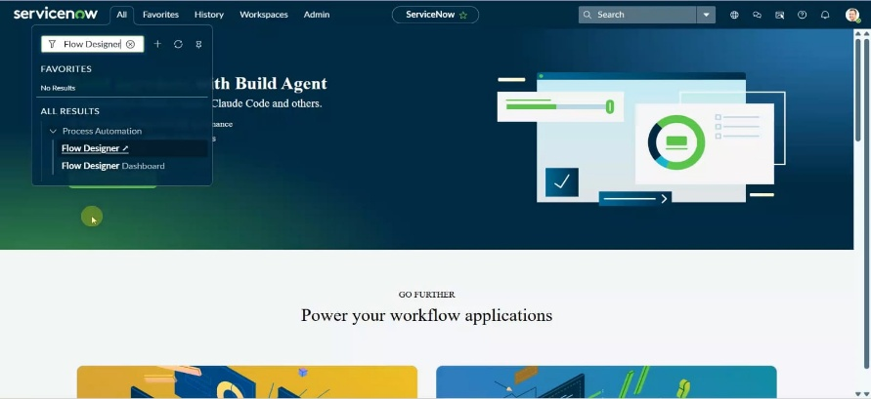
Screenshot 2 – Standard Laptop Catalog Item
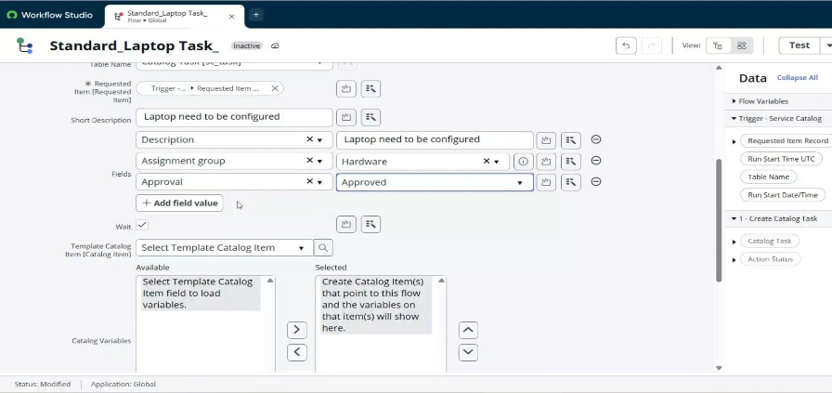
Screenshot 3 – Flow Designer
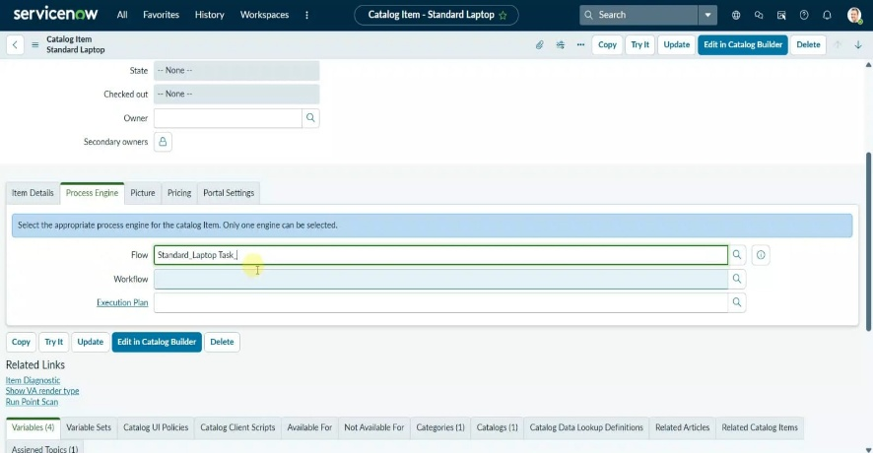
Screenshot 4 – Create Catalog Task Configuration
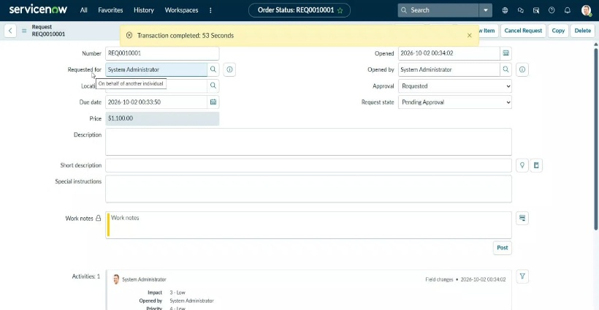
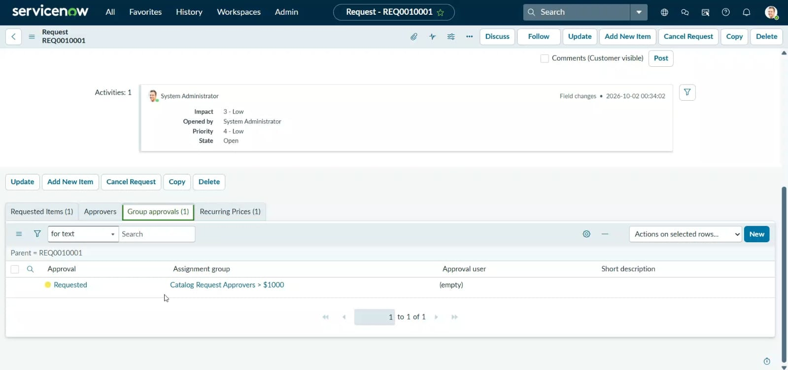
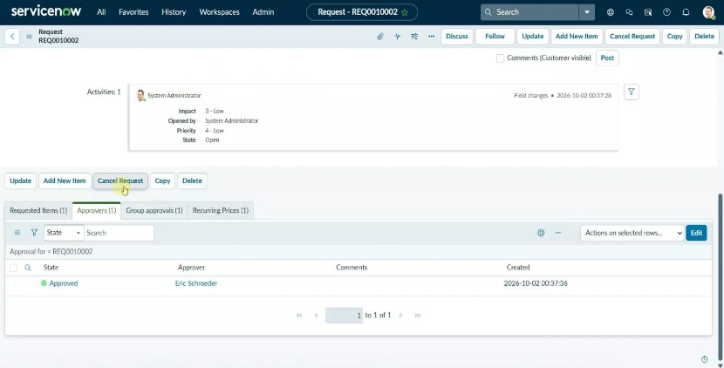

Screenshot 5 – Order Now
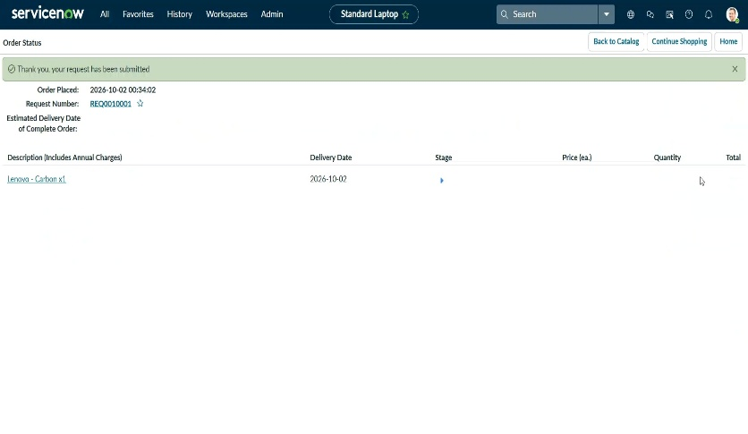
Screenshot 6 – Request Number
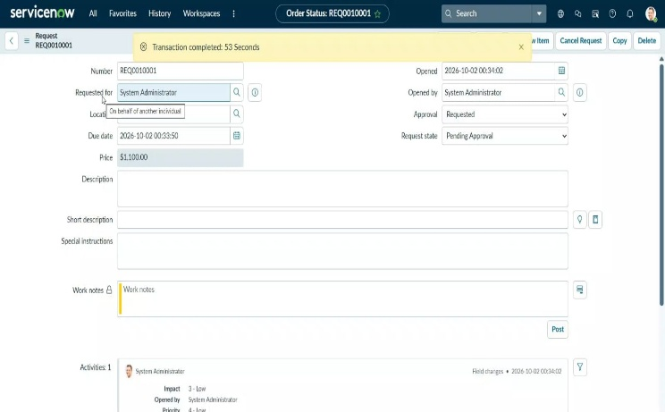
Screenshot 7 – Requested Item
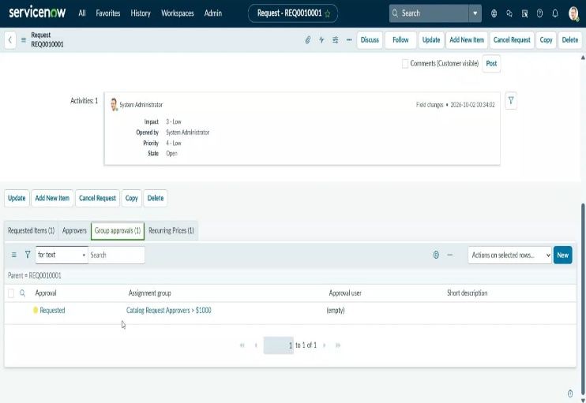
Screenshot 8 – Catalog Task
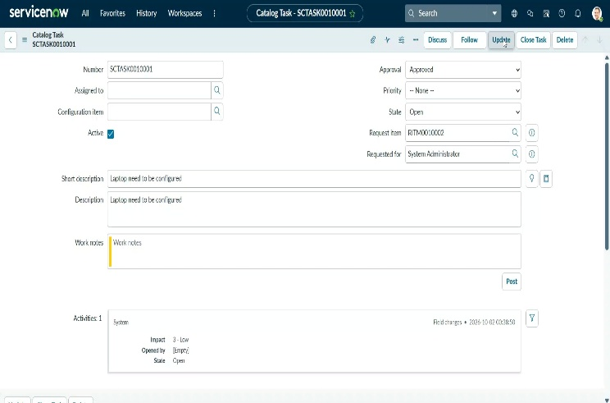
Result Summary
The project successfully demonstrates automated Standard Laptop procurement using ServiceNow Flow Designer. The Service Catalog request triggers the configured flow, which automatically creates a Catalog Task and assigns it to the Hardware group.

8. ADVANTAGES & DISADVANTAGES
Advantages
- Reduces manual effort by automatically creating Catalog Tasks.
- Improves consistency by using predefined task values.
- Automates task assignment to the Hardware group.
- Simplifies request submission through Service Catalog.
- Improves traceability through Request, Requested Item, and Catalog Task records.
- Reduces repetitive administrative work for IT teams.
- Easy to maintain using Flow Designer's visual workflow interface.
- Improves process standardization for standard laptop requests.
Disadvantages
- The current workflow is primarily designed for standard laptop requests.
- Changes in procurement policies may require flow configuration updates.
- The workflow depends on correct ServiceNow configuration.
- Incorrect catalog item or flow configuration can affect task creation.
- More complex procurement scenarios may require additional flows, approvals, or integrations.
- External procurement systems are not included in the basic implementation.
9. CONCLUSION
The Streamlining IT Procurement: Automating Standard Laptop Orders with Flow Designer project successfully demonstrates how ServiceNow can be used to automate a standard IT procurement process.
The solution integrates the Service Catalog with Flow Designer to automate the creation of a Catalog Task whenever a Standard Laptop request is submitted. The workflow automatically populates the task information and assigns the task to the Hardware group.
The implemented process provides a structured workflow:
Standard Laptop Request → Request → Requested Item → Flow Designer → Catalog Task → Hardware Group
Functional and UAT testing were performed to verify the workflow. The testing covered request submission, flow execution, Catalog Task creation, task field validation, assignment, and end-to-end processing. No defects were identified during the reported UAT testing.
Overall, the project demonstrates the use of ServiceNow automation to reduce manual activities and standardize the processing of IT equipment requests.

10. FUTURE SCOPE
The project can be extended with additional ServiceNow capabilities.
1. Automated Approval
Implement manager-based approval before the laptop request proceeds to fulfillment.
2. Inventory Integration
Integrate with an IT asset or inventory system to check laptop availability automatically.
3. Asset Creation
Automatically create or update an Asset/Configuration Item (CI) record when a laptop is assigned to an employee.
4. Automated Notifications
Send notifications to the requester when:
- Request is submitted.
- Request is approved.
- Catalog Task is assigned.
- Laptop is ready.
- Request is completed.
5. Multiple Laptop Types
Extend the catalog to support:
- Standard Laptop
- High-Performance Laptop
- Developer Laptop
- Business Laptop
6. Conditional Approval
Different laptop types or costs could require different approval levels.
7. Procurement Integration
Integrate ServiceNow with external procurement systems to automatically initiate purchase orders.
8. SLA Management
Configure SLAs to monitor the time taken to process and fulfill laptop requests.
9. Reporting and Dashboards
Create ServiceNow reports and dashboards to monitor:
- Number of laptop requests.
- Pending requests.
- Completed requests.
- Average fulfillment time.
- Hardware team workload.
10. Automated Asset Lifecycle
Extend the solution to support the complete laptop lifecycle, including:
Request → Approval → Procurement → Assignment → Maintenance → Replacement → Retirement
11. APPENDIX
GitHub Repository:
https://github.com/vampire622/Streamlining-IT-Procurement-Automating-Standard-Laptop-Orders-with-Flow-Designer
Project Demo Link:
https://drive.google.com/drive/folders/1cejlcV-IwhKyUWHhnpRb183GD14aG3RU?usp=drive_link

